Past, Present, Future: Outdoor Climate Education

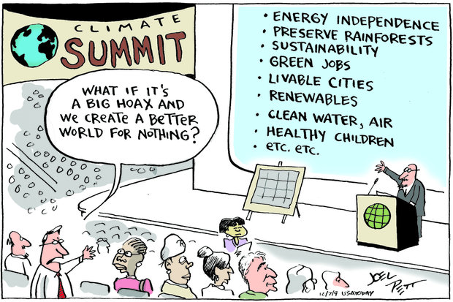

26th Annual Utah Environmental Education Conference
March 17-19, 2016
Moab, UT

Maura Hahnenberger, PhD
Assistant Professor, Geosciences Department, Salt Lake Community College

Twitter: @DrMaura_Science
E-mail: mhahnenb@bruinmail.slcc.edu
SLCC Geosciences: http://www.slcc.edu/geosciences/
Professional Website: http://hahnenberger.weebly.com/
WaterGirls Outreach Program: http://iutahwatergirls.weebly.com/
iUTAH Epscor Science for Utah’s Water Future: http://iutahepscor.org/

Summary:
Climate change can be an overwhelming topic for educators, so in this session we will utilize the basic skills of scientific observation to investigate past, present, and future Utah climates. This interdisciplinary experience will incorporate aspects of geology, ecology, meteorology, and hydrology, to make inferences about climate changes over time.

Maps to Millcreek Waterfall Hike:
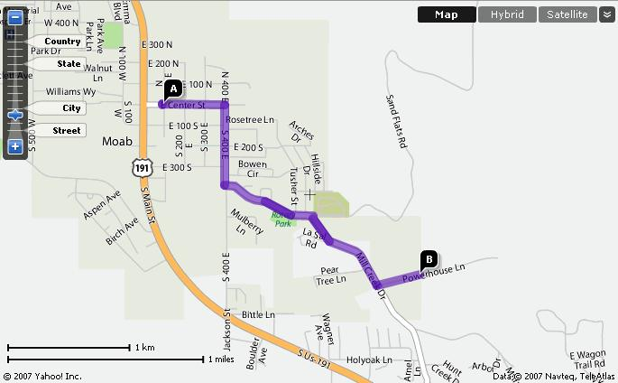

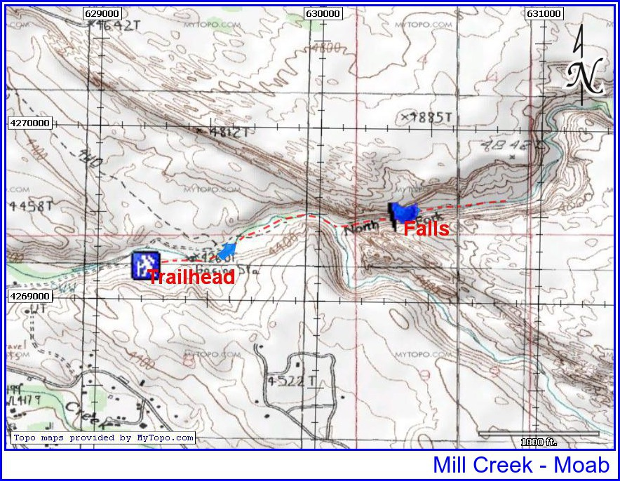
Module 1: Past Climates of Utah

Guiding questions:
- How do scientists know about past climates of Earth?
- What would you expect to see in a climate that was much hotter & drier or much colder & wetter than today?
- What causes global climate to change?

Further Resources:
- Utah a Geologic History: http://geology.utah.gov/popular/general-geology/geologic-history/utah-a-geologic-history/
- How can sedimentary rocks tell you about Utah's history?: http://geology.utah.gov/map-pub/survey-notes/glad-you-asked/how-can-sedimentary-rocks-tell-you-about-utahs-history/
- Geologic Guide to the Canyonlands travel Region: http://files.geology.utah.gov/online/pdf/pi-34.pdf

Observation Prompt:
- Draw a quick sketch/outline of one of the rock formations you see.
- Add to the sketch other observations you have of the rock formation. (e.g. color, texture, shape)

Inferences & Questions:
- What do you think the climate might have been like when these rock layers formed? Why?
- What do you think the features of the rock mean? (e.g. color, texture, shape)
- What new or remaining questions do you have?

Canyon Country Rock Layers: Moab Area Rock Layers:
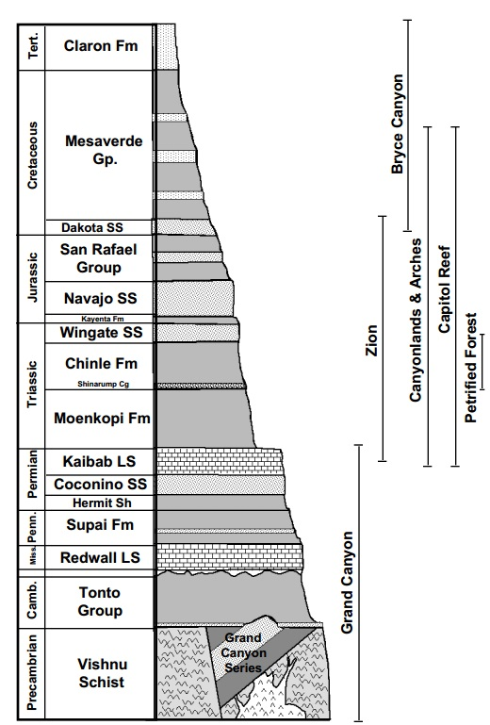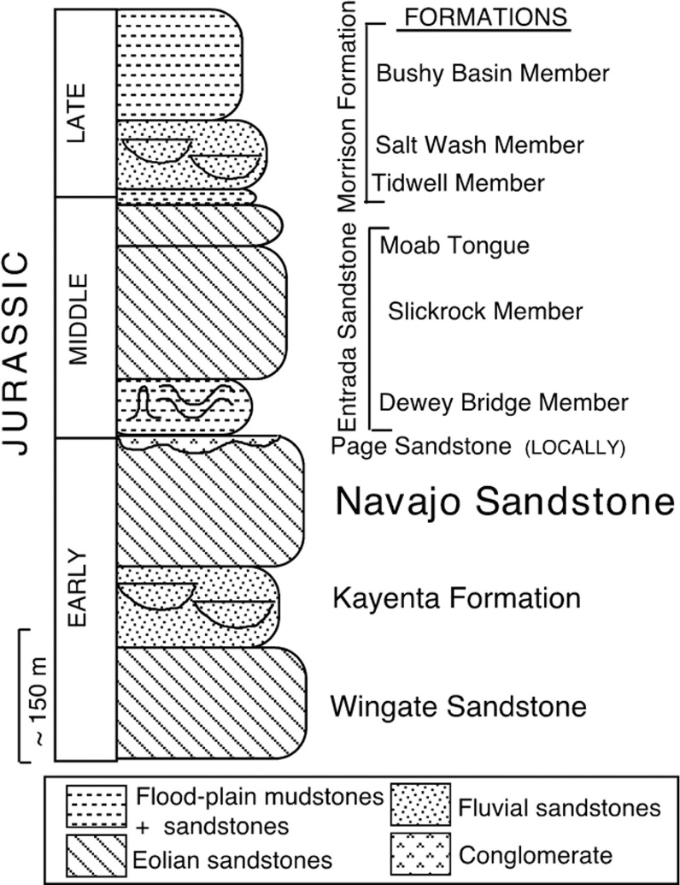

Utah: A Geologic History
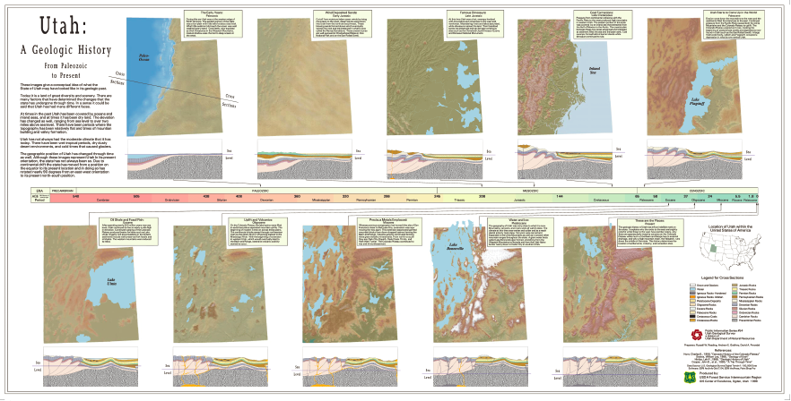

Controls on Global Climate:

Paleoclimate Proxies:
- Ice core records - deep ice cores, such as those from Lake Vostok, Antarctica, the Greenland Ice Sheet Project, and North Greenland Ice Sheet Project can be analyzed for trapped gas, stable isotope ratios, and pollen trapped within the layers to infer past climate.
- Tree rings - can be counted to determine age. The thickness of each ring can be used to infer fluctuations in temperature and precipitation, since optimal conditions for the particular species will result in more growth, and thus thicker rings for a given year. Scars and burn marks can indicate past natural events such as fire.
- Sediment cores - can be analyzed in many ways. Sediment layers can indicate sedimentation rate through time. Charcoal trapped in sediments can indicate past fire events. Remains of organisms such as diatoms, microbiota, and pollen within sediment can indicate changes in past climate, since each species has a limited range of habitable conditions. These organisms can become buried within the sediment. Thus, climate change can be inferred by species composition within the sediment.
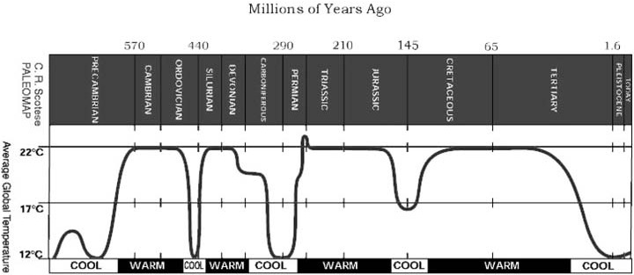

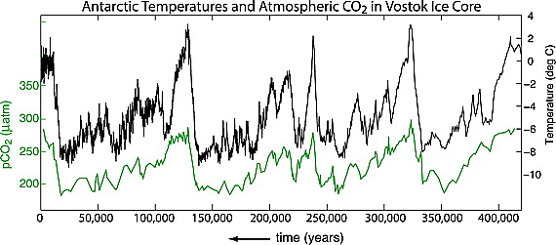
Module 2: Present Climates of Utah

Guiding questions:
- What controls local climates?
- What types of plants/animals live in different climates?
- What characteristics do plants/animals share when they live in a similar climate?

Further Resources:
- Utah Climate Center: https://climate.usurf.usu.edu/
- Utah Master Naturalist Field Books: https://extension.usu.edu/utahmasternaturalist/htm/learn/resources

Observation Prompt:
- Describe as many different plants/animals in your location as you can. Use words or sketches.
- What water sources or evidence of water are nearby? Describe.
- How abundant are the plants/animals you described?

Inferences & Questions:
- What similarities are there between different plants/animals in your location? Why might they be similar?
- Is the abundance or type of plants/animals different near or far from the water?
- How would you describe the climate of your location, based on your observations?
- What new or remaining questions do you have?

Controls on Local Climate:

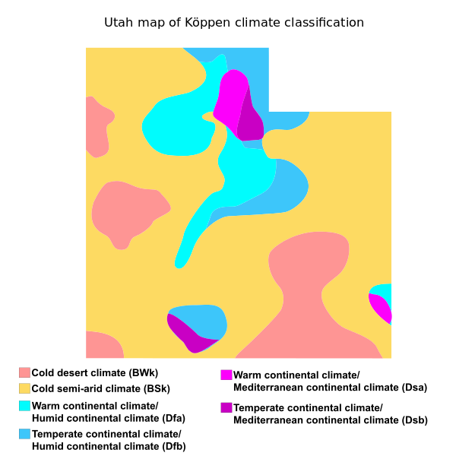

Module 3: Future Climate of Utah

Guiding questions:
- What factors might change the climate in the future?
- How do humans influence climate?
- What impact will a rapidly changing climate have on people and ecosystems?

Further Resources:
- Climate Assessment for the Southwest: http://www.climas.arizona.edu/
- National Climate Assessment for Southwest: http://nca2014.globalchange.gov/report/regions/southwest
- iUTAH Science for Utah’s Water Future: http://iutahepscor.org/

Observation Prompt:
- Imagine the climate at your location were warmer and drier than it is currently? What might be the impact on the plants, animals, or water you observed? What do you think would be different?
- Native Americans lived here at times when the climate was similar to today, but may have been colder and wetter at times. What might have been different?
- How could we confirm our ideas about what things might be like if it were warmer and drier or colder and wetter?

Inferences & Questions:
- How might plants or animals adapt if their climate changed? How could they survive?
- How much change do you think would be needed for a plant or animal to die or, even, go extinct? Do you think it is the same for all plants/animals?
- What new or remaining questions do you have?

Greenhouse Gas Emissions: Global Temperature:
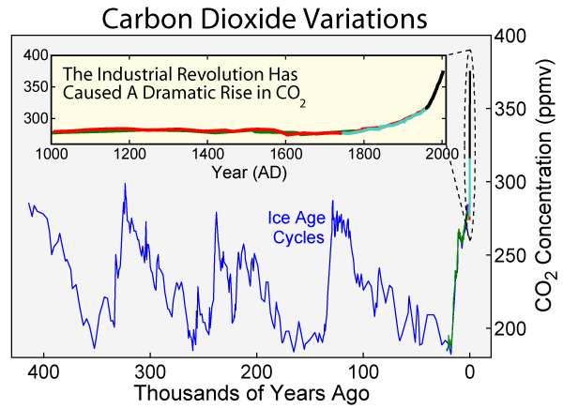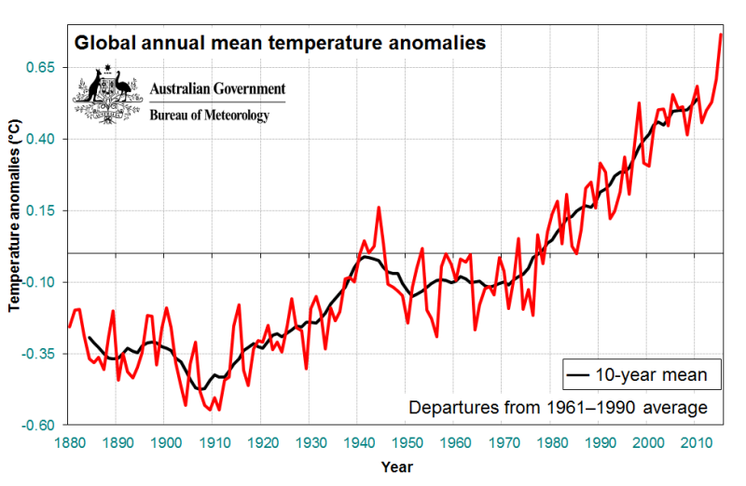

Climate Change Mind/Concept Map:
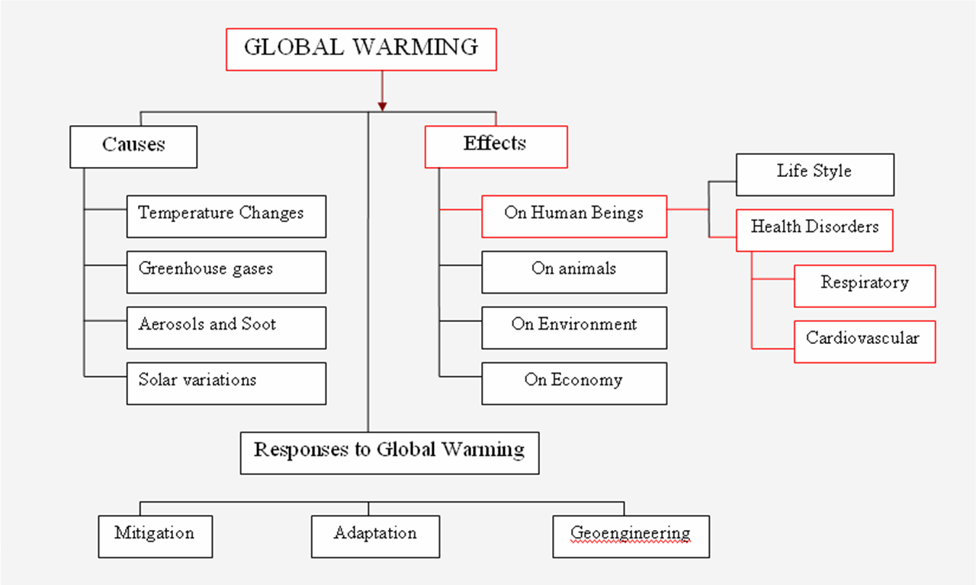

Final Reflections:
How did you think about climate and climate change before this session and how you think about it now?

Have any of your assumptions or understandings about the topic or how it can be taught changed? Why?

How can you apply what you learned during this session to your role as an educator?

Choose a topic related to climate or climate change and create a mind/concept map of the key components of that topic.

